­­­­­­

**CST-235 Java Application Programming Project Status and Design Report**

|  |  |  |
| --- | --- | --- |
| **Topic:** | *Topic 7: Security in Enterprise Java* | |
| **Date:** | *12/20/2020* | |
| **Revision:** | *Version 6.0* | |
| **Team:** | 1. *Micah Miller* | |
| 1. Vrijesh Patel | |
| 1. Austin Driver | |
|  | |
| **Weekly Team Status Summary:** | |  |  |  |  | | --- | --- | --- | --- | | **User Story** | **Team**  **Member** | **Hours**  **Worked** | **Hours Remaining** | | *Updated the Project Report and combined the Milestone files into one folder. Updated the Product Backlog, Sprint Backlog, and the Burndown chart.* | *Micah Miller* | *3* | *0* | | *Vrijesh did a great job on working with the code of the project by implementing the REST services to getJSON and getXML.* | *Vrijesh Patel* | *4* | *0* | | *Austin was the Scrum master for the project and helped keep us on track on completing the Milestone on time. Helped guide the project process and helping when possible. Also, helped with the majority of the Final Project Presentation and gathering data for the PowerPoint.* | *Austin Driver* | *3* | *0* | | |
| **GIT URL:** | [*https://github.com/AuziMan/CST-235-Project*](https://github.com/AuziMan/CST-235-Project)  *https://github.com/mmiller2321/CST-235* | |
| **Peer Review:** | *Y* | We acknowledge that our team has reviewed this Report and we agree to the approach we are all taking. |

**Planning Documentation**

**Agile Scrum Product Backlog:**

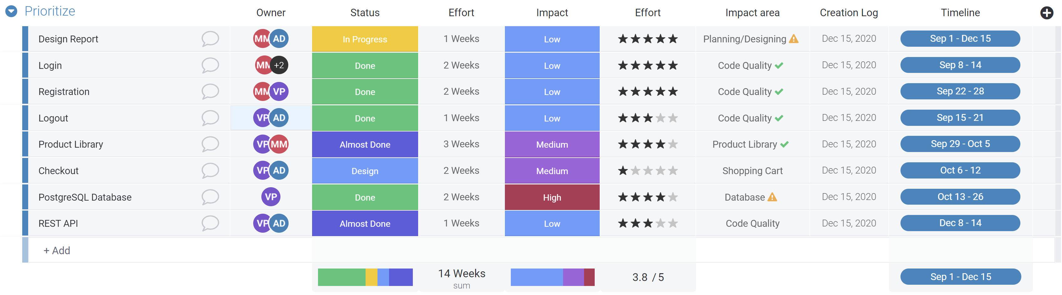

**Agile Scrum Sprint Backlog:**

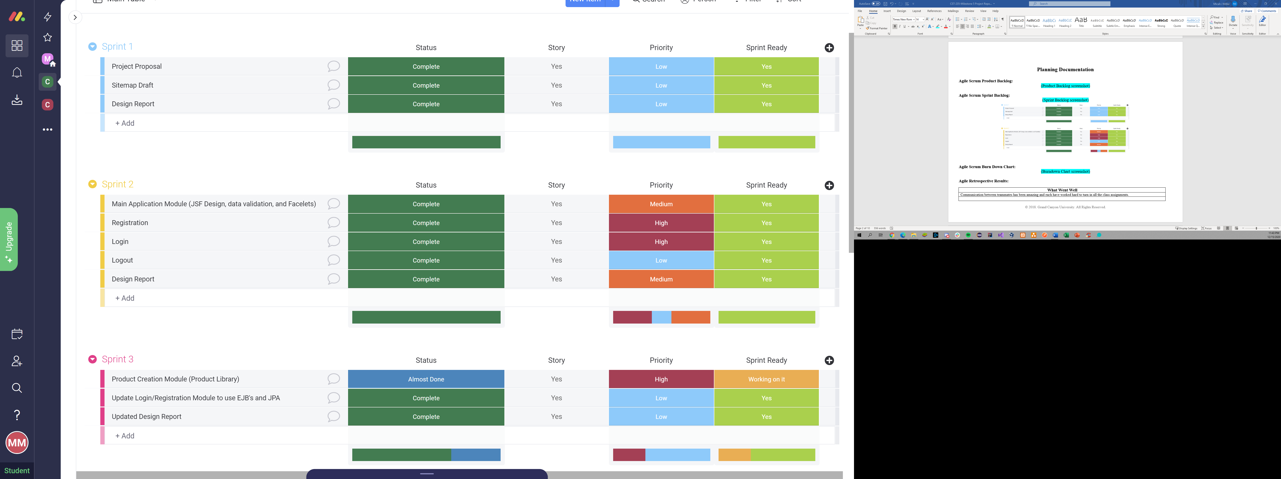

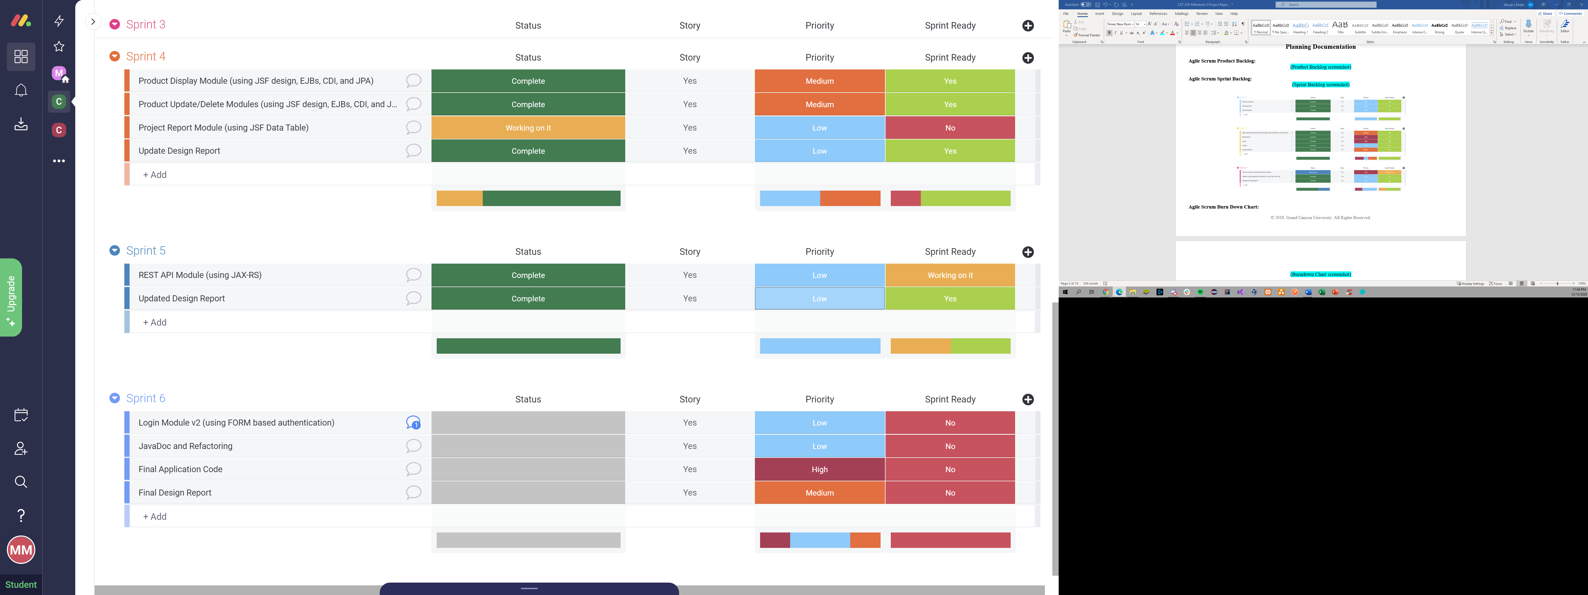

**Agile Scrum Burn Down Chart:**

**Agile Retrospective Results:**

|  |
| --- |
| **What Went Well** |
| Communication between teammates has been amazing and each have worked hard to turn in all the class assignments. |
|  |
|  |

|  |  |  |
| --- | --- | --- |
| **What Did Not Go Well** | **Action Plan** | **Due Date** |
| We were unsure of how to connect a database to our Project at first | We Compared our project to an online tutorial and that allowed us to figure out how to get a database to work. | 11.28.2020 |
|  |  |  |
|  |  |  |

**Design Documentation**

**General Technical Approach:**

*We decided to build a computer store e-commerce application. Each product will contain year built, model name, features, color, Size of Ram, processor type, hard drive, display type, operating system, and graphic card. We will have page for listing all product, add new product, delete product and search for a product.*

**Key Technical Design Decisions:**

*We will be using Java EE MVC patterns. We will have login page, welcome page, register page, product catalog, shopping cart page. We will also add admin sites like add a new product or edit a page. We chose this design because it is easier to navigate through the application and make changes where they may be needed.*

**Known Issues:**

*We do not have any known issues at this current time.*

**Risks:**

*User logging in with wrong credentials and gaining access. Losing data by not having a database in place. Making sure to use a good practical n-layer design architecture with a focus on security.*

**ER Diagram:**

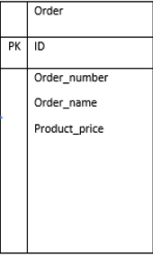 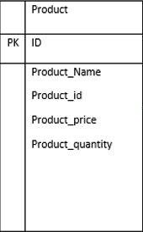

**DDL Scripts**

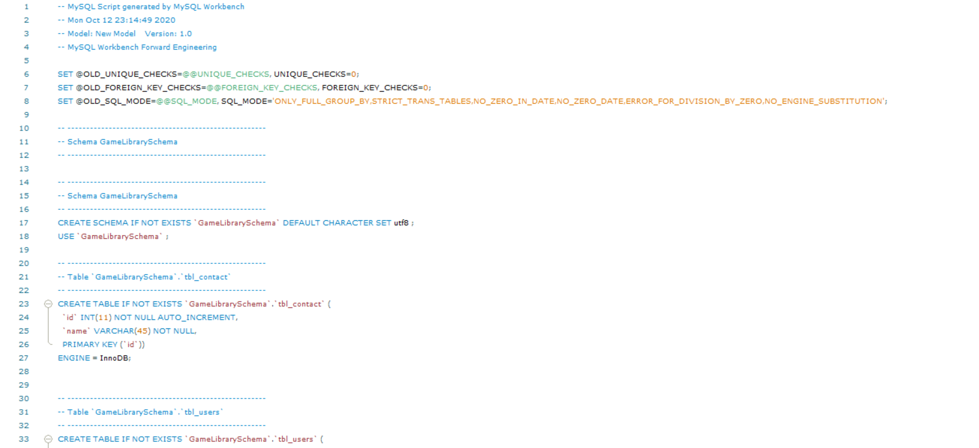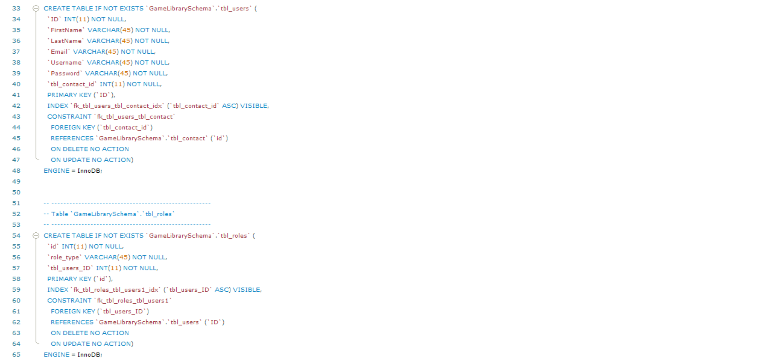

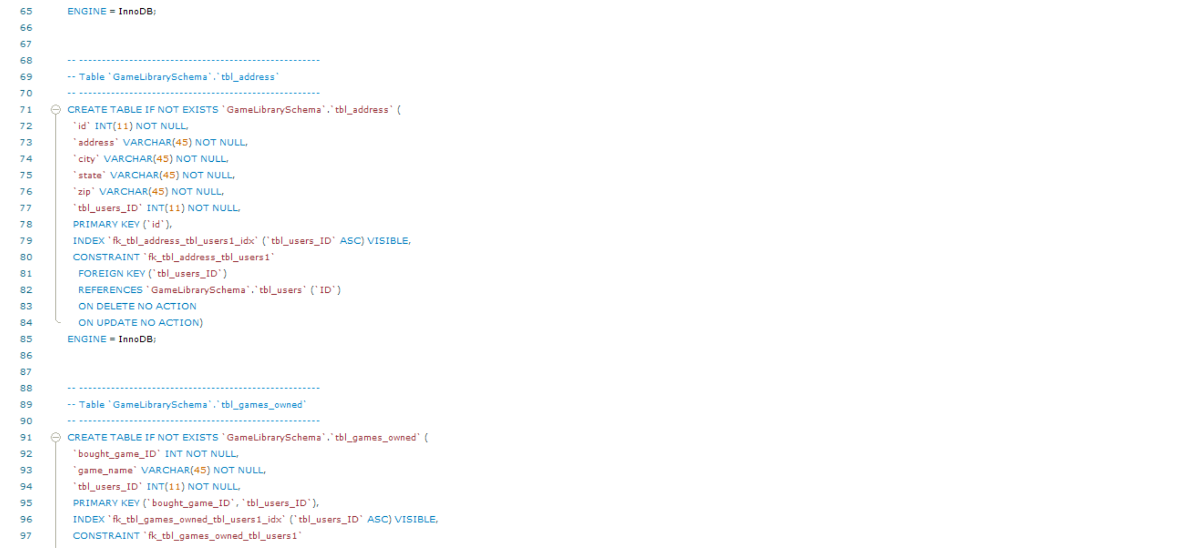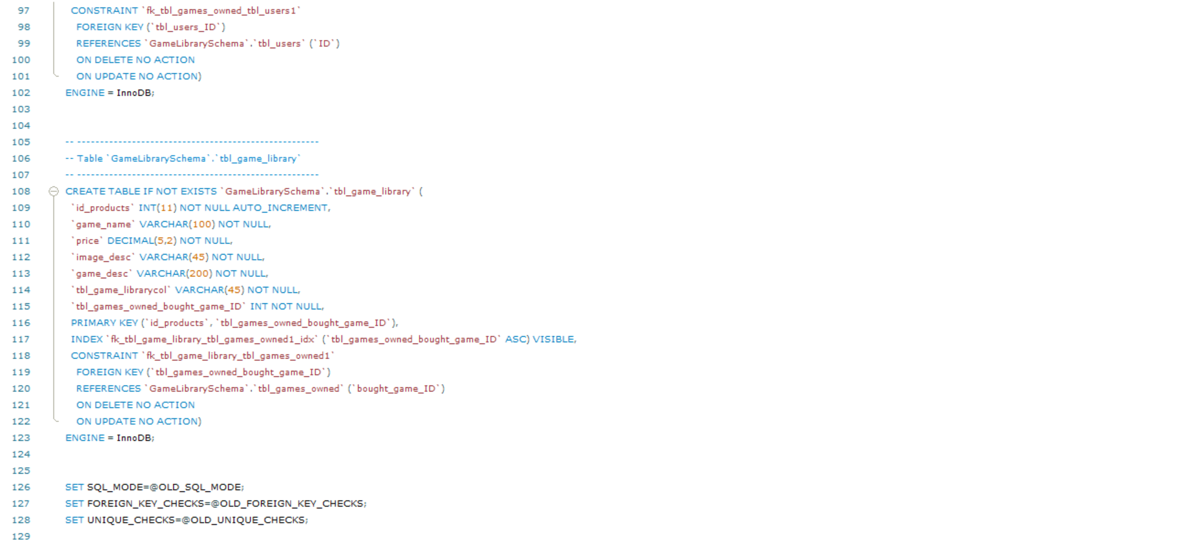

**Sitemap Diagram:**

**User Interface Diagrams:**

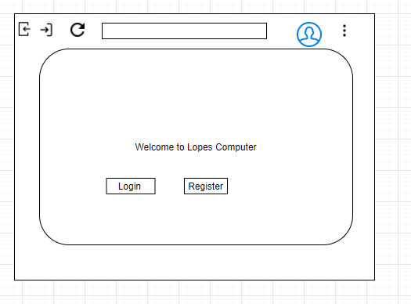

Here is the Home page, registration page, login page and the product catalog page.

**Class Diagrams:**

**Service API Design:**

*We have not gone over the API Design for the Milestone.*

**Security Design:**

*The two roles that will be implemented is the consumer role and the administrator role who has the power to edit the e-commerce website. Before you gain access to your product library you need to sign into the Windows application with your account details (username/password) you created. Once your account has been verified by your email you will be able to access your account. When you sign into the Windows app you have the option to “remember me” so you do not have to put your account details in every time.*

**Other Documentation:**

*We do not have any additional documentation or images to add on to the diagrams above.*